Radiocommunication Study Groups | 
Received: 27 April 2023  Source: Annex 5 to Document 5A/708  Subject: WRC-23 agenda item 9.1, topic b)  Resolution 774 (WRC-19) | Document 5A/730-E
 | 28 April 2023
 | English only
International Amateur Radio Union
Preliminary Draft New Report ITU-R M.[AMATEUR.CHARACTERISTICS]
Introduction
Report ITU-R M.2513-0 has been published following approval in SG 4. That report details studies on the potential for interference from the amateur and amateur satellite service applications in the range 1 240-1 300 MHz and terrestrial RNSS receivers operating in the same frequency range.
The IARU notes that those studies are based on static minimum coupling loss estimations that take no account of the amateur services deployment data and operating schedules despite information on these aspects being provided by the amateur radio community and included in the Report ITU-R M.2513-0.
The IARU believes that to properly understand the potential for interference and thereby develop proportionate guidance for the ongoing use of the band by the amateur services then these aspects need to be considered.
Proposal
Based on the parameters and operational information on the amateur and amateur satellite services in Annex 5 to 5A/708 an annex is proposed for the PDNR [AMATEUR.CHARACTERISTICS] detailing a study that assesses the impact of various amateur service transmitters on a population of RNSS receivers.
The proposed annex is provided in Attachment 1.
A short consequential addition to the main body of the report is provided in Attachment 2.

ATTACHMENT 1
Annex 1: Assessing the Extent of Interference between an Amateur Station and a population of RNSS Receivers operating co-frequency and in the same area.

1.0 Introduction
This study aims to quantify the extent of interference occurring between a station of the amateur service and a population of RNSS receivers around that station. Simulations assuming the following scenarios have been carried out:
a) Fixed narrow band amateur “Home” station and static RNSS receivers in fixed locations where the number of receivers is based on the population density and an estimated RNSS receiver “ownership” factor.
b) Fixed narrow band amateur “Home” station and mobile RNSS receivers, on board moving cars.
c) Fixed broadband amateur “Home” station (ATV) and mobile RNSS receivers, on board moving cars.
d) Fixed narrow band amateur “Permanent” station (e.g. voice repeater output channel) and mobile RNSS receivers, on board moving cars.
e) Fixed broadband amateur “Permanent” station (e.g. ATV repeater output channel) and mobile RNSS receivers, on board moving cars.
Each simulation calculates the signal level received by the individual RNSS receivers from an amateur station transmitter. The simulation area depends upon the amateur station density and the number of RNSS receivers placed in the area is based on assumptions about the population and ownership factor.
In case a) above the RNSS receivers remain fixed but are re-positioned for each run of the simulation. In the remaining cases b) to e) the mobile RNSS receivers are moved between each set of calculations according to a vehicle speed and trajectory across the simulation area. For each simulation run a new set of vehicle starting positions and speed assignments are made.
The received levels are compared to the protection criteria and if above this level the receiver is labelled ”impacted” so that the statistics of the impacted receivers can be collated to determine the mean percentage of impacted receivers from the simulation population.

2.0 Fixed Home Station and Fixed RNSS Receiver Scenario
In this simulation fixed amateur home stations and fixed RNSS receivers are considered. The number of receivers is based on the population density and an estimated “ownership” factor. RNSS receivers are considered to be in fixed locations and the number of receivers is based on the population density and an estimated RNSS receiver “ownership” factor.

2.1 Simulation areas and propagation model parameters
The amateur station densities are the same as those documented in section 5 of the main report.
The amateur station density assumed in all simulations:
• Average Home Station and Portable station density = 1 station / 5 000 km²
• Minimum Home Station and Portable station density = 1 station / 16,700 km²
• Maximum Home Station and Portable station density = 1 station / 625 km²

The simulation area according to each amateur station density:
• Average Home Station and Portable station density = 70 x 70 km
• Minimum Home Station and Portable station density = 130 x 130 km
• Maximum Home Station and Portable station density = 25 x 25 km
The propagation model parameters are:
• Recommendation ITU-R P.1546 Matlab code provided by ITU. Latest update (3rd May 2019) is available from https://www.itu.int/md/R15-WP3K-C-0289/en.
• Location variability: 50%
• Required percentage time: 1%

2.2 Population Density
The study was based on population data for France, based on National Institute for Statistics (INSEE):
Figure 1
Population density data extract for France
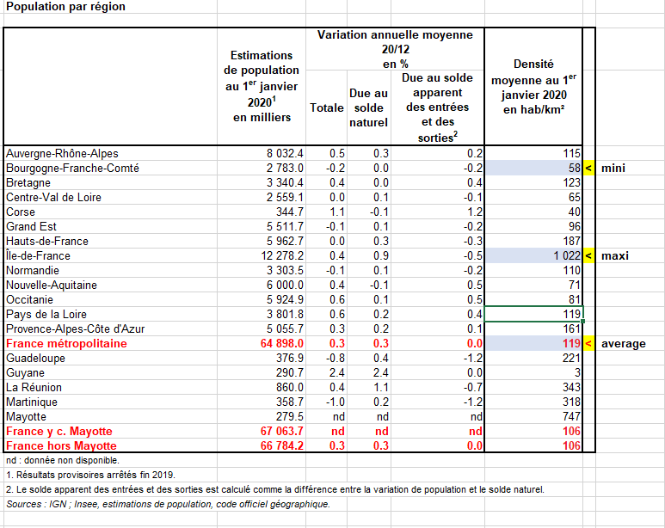
Three different population densities are identified:
1 “Rural”, typically Bourgogne, with a density of 58 inhabitants / km²
2 “Urban”: Paris & direct suburbs (Ile de France), 1022 inhabitants / km²
3 “Average”: France average is 119 inhabitants / km²

2.3 Simulation Parameters
The following parameters were assumed for the amateur home station and the RNSS receivers:
• Average, minimum and maximum home station density.
• Simulation area: According to the station density.
• Transmitter frequency: 1 297 MHz
• Transmitter Antenna gain: 18 dBi
• Transmitter power: 150 Watts
• Effective height of the amateur station antenna: 12 meters
• Receiver antenna height: 1.5 meters
• Narrow band receiver max interference threshold: –134.5 dBW
• Receiver antenna gain: –6 dBi, omnidirectional.
• Polarisation Loss = 3 dB
• Rec. ITU-R P.1546 ‘area’ parameter: rural, urban and dense urban
• Rec. ITU-R P.1546 clutter height: 10 m, 20 m and 30 m (according to rural, urban or dense urban area parameter respectively).
• Location variability: 50%
• Required percentage time: 1%
• Use ratio: 10% of the population is using the RNSS receiver at simulation time.
The potential number of victim receivers (N) = (Simulation area) * (Population density) * (Use ratio)

2.4 Simulation Method
At each simulation iteration step (one run), the victim receivers are randomly placed in the simulation area. The (x, y) coordinates of each receiver are initialized from two distinct random uniform distributions.
For each receiver we compute:
• Distance to the transmitter,
• Angle to the main lobe of the transmitter antenna.
From the angle to the main lobe, the antenna gain is estimated according to Recommendation ITU-R F.1336-5. Then the received level is computed as:
• Received level = (transmitter power) + (transmitter antenna gain) + (receiver antenna gain) - (path loss)
Where the path loss value is provided by the ITU-R P.1546 Matlab code.
Each time the received level is above the RNSS receiver interference threshold the receiver is counted as “impacted”.
At the end of one simulation step, we have m receivers impacted from a potential number of victim receivers N.
The percentage of impacted receivers from the simulation step is then defined as (m / N) * 100.
The simulation is performed 1 000 times and ends with 1 000 distinct values for the percentage of impacted receivers. From these the mean percentage of impacted RNSS receivers can be calculated.

2.5 Simulation Results
Mean percentage of fixed RNSS receivers within the simulation area impacted by one static amateur station operating as defined above:
Table 1
Mean Percentage of impacted fixed RNSS receivers and Standard Deviation
 | Minimum amateur station density |  | Average amateur station density |  | Maximum amateur station density
Area setting and population density | % Impacted RNSS Rx | Standard Deviation | % Impacted RNSS Rx | Standard Deviation | % Impacted RNSS Rx | Standard Deviation
Rural | 0.06% | 0.01% | 0.20% | 0.03% | 1.62% | 0.21%
Urban | 0.02% | 0.004% | 0.08% | 0.01% | 0.65% | 0.09%
Dense urban | 0.02% | 0.001% | 0.06% | 0.001% | 0.45% | 0.02%

3.0 Fixed Amateur Home Station and Mobile RNSS Receivers Scenario
In this section the impact on moving RNSS receivers located in cars is considered. Both the amateur service narrow band emission and amateur service broadband emission with the appropriate interference threshold value are considered.

3.1 Simulation Method
The first simulation step selects random locations for each car according to the vehicle density and simulation area, assigning them a random speed (from 10 to 50 km/h in urban area) and a random direction. Each car then moves along the selected heading for 15 minutes (maximum assumed amateur transmission duration). Every 5 seconds (180 individual time steps in 15 minutes), the received level is computed and compared to the RNSS receiver maximum interference threshold.
Figure 2
Mobile RNSS receiver simulation scenario
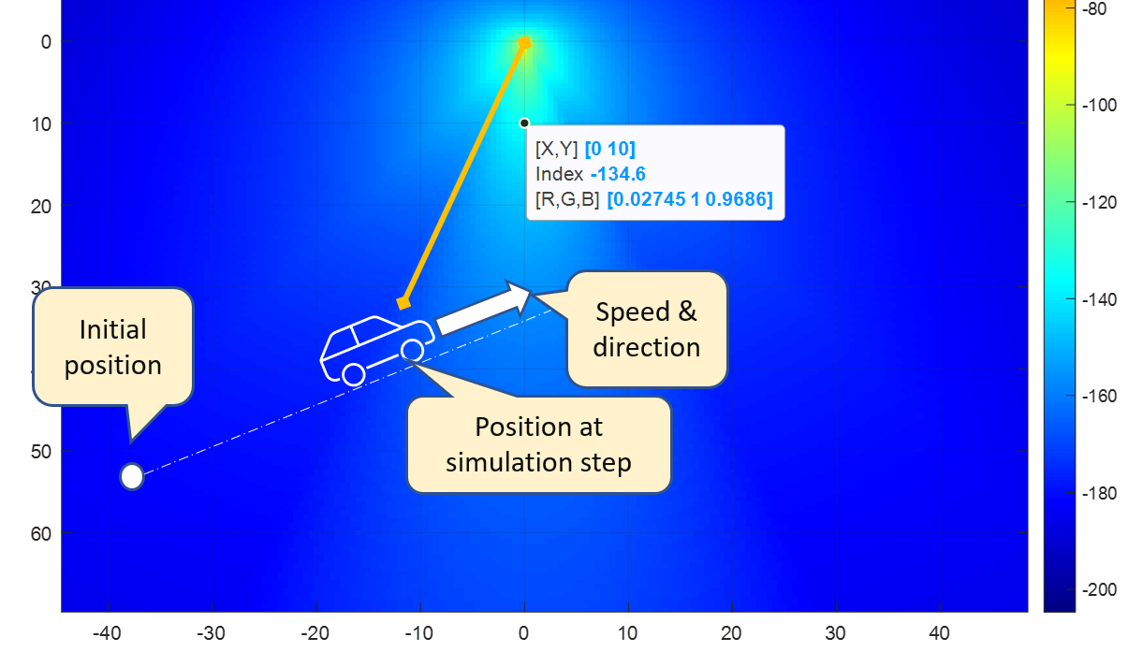
At the end of each simulation step we compute:
The percentage of “impacted” RNSS receivers that have faced interference above the protection threshold.
This process is repeated 100 times and the mean percentage and standard deviation are calculated and presented in the results.

3.2 Narrow Band Amateur Home Station

3.2.1 Simulation parameters
The same section 2.3 simulation parameters were used here with the addition of the following vehicular assumptions:
• Car density: 330 vehicles/km² (according to ECC Report 351 for the urban case)
• Percentage of cars having an active RNSS receiver during the simulation: 50%
• Speed distribution: uniform, from 5 to 50 km/h,
• Simulated drive path duration for each simulation step: 15 minutes,
• Time step for the drive path: 5 seconds, leading to 180 steps for 15 minutes.
Note: In this simulation, if a RNSS receiver moves outside of the simulation area, it turns around back into the area. Thus the number of RNSS receivers inside the simulation remains constant.

3.2.2 Simulation Results
Mean percentage of mobile RNSS receivers impacted by one fixed narrowband amateur home station:
Table 2
Narrow Band Amateur Home Station: Mean Percentage of impacted mobile RNSS
receivers and Standard Deviation

 | Minimum amateur station density |  | Average amateur station density |  | Maximum amateur station density
Area Setting Parameter | % Impacted RNSS Rx | Standard Deviation | % Impacted RNSS Rx | Standard Deviation | % Impacted RNSS Rx | Standard Deviation
Rural | 0.15% | 0.002% | 0.50% | 0.008% | 3.94% | 0.058%
Urban | 0.079% | 0.001% | 0.27% | 0.006% | 2.10% | 0.046%
Dense urban | 0.06% | 0.0015% | 0.21% | 0.0047% | 1.67% | 0.038%

3.3 Broadband Amateur Home Station

3.3.1 Simulation Parameters
The same simulation parameters and vehicular assumptions were used as detailed in section 3.2.1 but in this case using the RNSS receiver broadband interference threshold:
For the amateur service broadband emission:
• Broadband emission bandwidth: 2 MHz (DATV signal)
• Broadband RNSS receiver max interference threshold: –140 dBW/MHz

3.3.2 Simulation Results
Mean percentage of mobile RNSS receivers impacted by one fixed broadband amateur home station:
Table 3
Broadband Amateur Home Station: Mean Percentage of impacted mobile
RNSS receivers and Standard Deviation
 | Average amateur station density
Area Setting Parameter | % Impacted RNSS Rx | Standard Deviation
Rural | 0.612% | 0.008%
Urban | 0.325% | 0.006%
Dense urban | 0.26% | 0.01%

4.0 Permanent Amateur Station and Mobile RNSS Receivers Scenario
In this simulation, the amateur station parameters are changed to those appropriate for a fixed permanent station (repeater station output channel) and the impact on moving RNSS receivers located in cars is considered from both a narrow band amateur emission and a broadband amateur emission.

4.1 Simulation Method
The same simulation method was followed as used in the fixed amateur home station and mobile RNSS receiver scenario in section 3.1.

4.2 Narrow Band Amateur Permanent Station

4.2.1 Simulation Parameters
The following parameters identified in Section 5 of the main report were assumed for the amateur permanent station and the RNSS receivers:
• Average permanent station density = 1 station / 3333 km²
• Simulation area: According to the station density = 58 x 58 km
• Transmitter frequency: 1297 MHz
• Transmitter e.i.r.p.: 25 Watts
• Effective height of the amateur station antenna: 25 meters
• Receiver antenna height: 1.5 meter
• Narrow band receiver max interference threshold: –134.5 dBW
• Receiver antenna gain: –6 dBi, omnidirectional.
• Rec. ITU-R P.1546 ‘area’ parameter: Rural, Urban and Dense Urban
• Rec. ITU-R P.1546 clutter height: 10 m, 20 m and 30 m (according to the rural, urban or dense urban area parameter respectively)
• Location variability: 50%
• Required percentage time: 1%
Vehicular assumptions:
• Car density: 330 vehicles/km²
• Percentage of cars having an active RNSS receiver during the simulation: 50%
• Speed distribution: uniform, from 5 to 50 km/h,
• Simulated drive path duration for each simulation step: 15 minutes,
Time step for the drive path: 5 seconds, leading to 180 steps for 15 minutes.
Note: Again, if a RNSS receiver moves outside of the simulation area, it turns around back into the area. Thus the number of RNSS receivers inside the simulation remains constant.
4.2.2 Simulation Results
Mean percentage of mobile RNSS receivers impacted by one fixed narrow band permanent amateur station:
Table 4
Narrow Band Amateur Permanent Station: Mean Percentage of impacted mobile
RNSS receivers and Standard Deviation

Area Setting Parameter | % Impacted RNSS Rx | Standard Deviation
Rural | 0.24% | 0.01%
Urban | 0.13% | 0.005%
Dense urban | 0.1% | 0.005%

4.3 Broadband Amateur Permanent Station

4.3.1 Simulation parameters
The same simulation parameters and vehicular assumptions were used as detailed in section 4.2.1 but in this case using the RNSS receiver broadband interference threshold:
For the amateur service broadband emission:
• Broadband emission bandwidth: 2 MHz (DATV signal)
• Broadband RNSS receiver max interference threshold: –140 dBW/MHz

4.3.2 Simulation Results
Mean percentage of mobile RNSS receivers impacted by one fixed broadband amateur permanent station:
Table 5
Broadband Amateur Permanent Station: Mean Percentage of impacted mobile
RNSS receivers and Standard Deviation

Area Setting Parameter | % Impacted RNSS Rx | Standard Deviation
Rural | 0.68% | 0.01%
Urban | 0.34% | 0.01%
Dense urban | 0.26% | 0.01%

5.0 Observations
In the fixed RNSS receivers and static amateur home station case the percentage of impacted receivers in the simulation area population is less than 1% for all the most likely combinations of area setting and amateur station density. One case returns a value of 1.62% but this is considered an unlikely combination of maximum amateur station density and a rural propagation model setting. Generally, the percentage of impacted receivers is higher for the highest amateur station density case but even in the urban setting the percentage is less than 0.5%.
This trend is true also for the mobile RNSS receiver case and the percentages are again higher for the maximum amateur station density case. However in the most likely combinations of area setting and station density, the percentage of impacted receivers in the simulation area population is mostly less than 1%. For an amateur station with an assumed broadband emission, the mean percentage of impacted RNSS receivers for an average amateur station density (based on narrowband station density) remains below 1%.
For the permanent amateur station (narrow band or broadband repeater output channel) and mobile RNSS receiver case only a single average density figure is available. All the mean percentage results for impacted RNSS receivers are less than 1%.
To ensure their statistical validity, the simulations employ a large population of RNSS receivers. For example, in the mobile RNSS receiver simulation for the average amateur station density over 2.75 million active RNSS mobiles are considered in the simulation area. The low standard deviation figures provide good confidence in the results.
These results should be considered alongside the operational data estimating the amount of time that amateur stations are actively transmitting. For example, and for narrow band operations this amounts to less than 3% of time across a year.
These simulations consider any improvement in interference resilience brought about by frequency offset from the RNSS system centre frequency. In addition, the continuous transmitting time of 15 minutes assumed in the simulations is excessive for a home station although it could be reasonable for a permanent station.

6.0 Conclusions
This study shows that the percentage of a population of fixed or mobile RNSS receivers that might suffer interference from either a Home Station or a Permanent Station operating in the amateur service is very low.

ATTACHMENT 2
Changes proposed for the main body of Annex 5 to 5A/708:
New section 5.8 between the existing 5.7 and 5.8:

5.8 Impact of Amateur Station Emissions
Using the parameters and operational data in the sections above, simulations have been carried out to assess the impact of certain amateur station emissions on a population of co-frequency RNSS receivers. These are detailed in Annex 1.
____________

