Radiocommunication Study Groups | 
Source: Document 4C/TEMP/155  Subject: WRC-23 agenda item 9.1, topic b)  Resolution 774 (WRC-19) | Annex 3 to  Document 4C/445-E
 | 3 July 2023
 | English only
Annex 3 to Working Party 4С Chairman’s Report
Preliminary Draft Revision of Report ITU-R M.2513-0
Studies regarding the protection of the primary radionavigation-satellite service (space-to-Earth) by the secondary amateur and amateur-satellite services
in the frequency band 1 240-1 300 MHz
(2022)
Summary of revision
This Report is revised by adding new Annex as Annex 9.
…

10.4 Impact of amateur station emissions
An example of how to assess the impact of certain amateur station emissions on a deployment simulation of a large number of one type of co-frequency RNSS (space-to-Earth) receivers is attached as Annex 9. Monte-Carlo methodology is used in this study. Different methodologies or different assumptions would result in different calculation results.
….
{Editor’s Note: As currently done for Report ITU-R M.2513, the proposed new Annex, Annex 9, should be attached to Report ITU-R M.2513 by embedding a separated file.}
Annex 9
An example of how to assess the impact of certain amateur station emissions on a deployment simulation of a large number of one type of co-frequency
RNSS (space-to-Earth) receivers

1 Introduction
This study provides an example of how to quantify the extent of interference occurring between a station of the amateur service and a population of RNSS receivers around that station. Simulations assuming the following scenarios have been carried out:
a) Fixed narrow band amateur “Home” station and static RNSS receivers in fixed locations where the number of receivers is based on the population density and an estimated RNSS receiver “ownership” factor.
b) Fixed narrow band amateur “Home” station and mobile RNSS receivers, on board moving cars.
c) Fixed broadband amateur “Home” station (ATV) and mobile RNSS receivers, on board moving cars.
d) Fixed narrow band amateur “Permanent” station (e.g. voice repeater output channel) and mobile RNSS receivers, on board moving cars.
e) Fixed broadband amateur “Permanent” station (e.g. ATV repeater output channel) and mobile RNSS receivers, on board moving cars.
Each simulation calculates the signal level received by the individual RNSS receivers from an amateur station transmitter. The simulation area depends upon the amateur station density and the number of RNSS receivers placed in the area is based on assumptions about the population and ownership factor.
In case a) above the RNSS receivers remain fixed but are re-positioned for each run of the simulation. In the remaining cases b) to e) the mobile RNSS receivers are moved between each set of calculations according to a vehicle speed and trajectory across the simulation area. For each simulation run a new set of vehicle starting positions and speed assignments are made.
The received levels are compared to the protection criteria and if above this level the receiver is labelled ”impacted” so that the statistics of the impacted receivers can be collated to determine the mean percentage of impacted receivers from the simulation population.
Similar to other studies in this Report, these simulations consider only amateur transmissions co-frequency with RNSS receivers Furthermore these simulations do not consider any impact of frequency offset from the RNSS system centre frequency.

2 Fixed home station and fixed RNSS receiver scenario
In this simulation fixed amateur home stations and fixed RNSS receivers are considered. The number of receivers is based on the population density and an estimated “ownership” factor. RNSS receivers are considered to be in fixed locations and the number of receivers is based on the population density and an estimated RNSS receiver “ownership” factor.

2.1 Simulation areas and propagation model parameters
The amateur station densities determine the simulation areas from a range from 0.00006 to 0.0016 stations/km2 with an average of 0.0002 stations/km².
The amateur station density assumed in all simulations:
– Average Home Station and Portable station density = 1 station / 5 000 km²
– Minimum Home Station and Portable station density = 1 station / 16,700 km²
– Maximum Home Station and Portable station density = 1 station / 625 km²
The simulation area according to each amateur station density:
– Average Home Station and Portable station density = 70 x 70 km
– Minimum Home Station and Portable station density = 130 x 130 km
– Maximum Home Station and Portable station density = 25 x 25 km
The simulation areas were populated with RNSS receivers in accordance with Table 1 for each propagation model area parameter (Rural, Urban or Dense Urban):
TABLE 1
Number of RNSS receivers placed in each simulation area
 | Minimum amateur station density | Average amateur station density | Maximum amateur station density
Rural | 96,860 | 29,000 | 3,625
Urban | 198,730 | 59,500 | 7,438
Dense Urban | 1,706,740 | 511,000 | 63,874

In order to check the appropriateness of these figures, population data for France was consulted, based on National Institute for Statistics (INSEE) and three different population densities can be identified:
1 “Rural”, typically Bourgogne, with a density of 58 inhabitants / km²
2 “Dense Urban”: Paris & direct suburbs (Ile de France), 1022 inhabitants / km²
3 “Urban”: France average is 119 inhabitants / km²
The RNSS receiver numbers in Table 1 can be attained assuming just a 10% active receivers across the population which might be pessimistic. The actual percentage of active receivers in final deployments may be higher and is yet to be determined.
The population of RNSS receivers for the simulation (N) = (Simulation area) * (Population density) * (Active Receivers).

2.2 Propagation model
The propagation model parameters are:
– Recommendation ITU-R P.1546 MATLAB code provided by ITU. Latest update (3rd May 2019) is available from https://www.itu.int/md/R15-WP3K-C-0289/en.
– Location variability: 50%
– Required percentage time: 1%

2.3 Simulation parameters
The following parameters were assumed for the amateur home station and the RNSS receivers:
– Transmitter frequency: 1 297 MHz
– Transmitter Antenna gain: 18 dBi
– Transmitter power: 150 Watts
– Effective height of the amateur station antenna: 12 meters
– Receiver antenna height: 1.5 meters
– Narrow band receiver max interference threshold: –134.5 dBW (Ref: ITU-R M.1902-2, Table 1, receiver type 3b).
– Receiver antenna gain: –6 dBi ((Ref: ITU-R M.1902-2, Table 1, receiver type 3b), 0 dBi and 3 dBi (Ref: ITU-R M.1902-2, Table 1, receiver type 3b) omnidirectional.
– Polarisation Loss = 3 dB
– Rec. ITU-R P.1546 ‘area’ parameter: rural, urban and dense urban
– An assumption regarding clutter height* of 10 m, 20 m and 30 m were taken (available values in variable R2 in the ITU-R MATLAB code, according to rural, urban or dense urban area parameter respectively).
*: A different clatter height of 0 m is also used in a different analysis such as those in Annexes 1, 3 and 7.
– Rec. ITU-R P.1546 Location variability: 50%
– Rec. ITU-R P.1546 Required percentage time: 1%

2.4 Simulation method
At each simulation iteration step (one run), the victim receivers are randomly placed in the simulation area. The (x, y) coordinates of each receiver are initialized from two distinct random uniform distributions.
For each receiver we compute:
– Distance to the transmitter,
– Angle to the main lobe of the transmitter antenna.
From the angle to the main lobe, the antenna gain is estimated according to Recommendation ITU-R F.1336-5. Then the received level is computed as:
– Received level = (transmitter power) + (transmitter antenna gain) + (receiver antenna gain) - (path loss)
Where the path loss value is provided by the ITU-R P.1546 Matlab code.
Each time the received level is above the RNSS receiver interference threshold the receiver is counted as “impacted”.
At the end of one simulation step, we have m receivers impacted from a potential number of victim receivers N.
The percentage of impacted receivers from the simulation step is then defined as (m / N) * 100.
The simulation is performed 1 000 times and ends with 1 000 distinct values for the percentage of impacted receivers. From these the mean percentage of impacted RNSS receivers can be calculated.

2.5 Simulation results
Mean percentage of fixed RNSS receivers within the simulation area impacted by one static amateur station operating as defined above:
Table 2
Mean percentage of impacted fixed RNSS receivers and standard deviation
RNSS receiver antenna gain = –6 dBi
 | Minimum amateur station density |  | Average amateur station density |  | Maximum amateur station density
Area setting and population density | % Impacted RNSS Rx | Standard Deviation | % Impacted RNSS Rx | Standard Deviation | % Impacted RNSS Rx | Standard Deviation
Rural | 0.06% | 0.01% | 0.20% | 0.03% | 1.62% | 0.21%
Urban | 0.02% | 0.004% | 0.08% | 0.01% | 0.65% | 0.09%
Dense urban | 0.02% | 0.001% | 0.06% | 0.001% | 0.45% | 0.02%

RNSS receiver antenna gain = 0 dBi
 | Minimum amateur station density |  | Average amateur station density |  | Maximum amateur station density
Area setting and population density | % Impacted RNSS Rx | Standard Deviation | % Impacted RNSS Rx | Standard Deviation | % Impacted RNSS Rx | Standard Deviation
Rural | 0.118% | 0.011% | 0.396% | 0.039% | 3.177% | 0.306%
Urban | 0.048% | 0.005% | 0.161%¹ | 0.017% | 1.287% | 0.134%
Dense urban | 0.033% | 0.001% | 0.111% | 0.005% | 0.889% | 0.037%

RNSS receiver antenna gain = 3 dBi
 | Minimum amateur station density |  | Average amateur station density |  | Maximum amateur station density
Area setting and population density | % Impacted RNSS Rx | Standard Deviation | % Impacted RNSS Rx | Standard Deviation | % Impacted RNSS Rx | Standard Deviation
Rural | 0.163% | 0.013% | 0.544% | 0.043% | 4.385% | 0.35%
Urban | 0.067% | 0.006% | 0.224%¹ | 0.019% | 1.779% | 0.154%
Dense urban | 0.047% | 0.002% | 0.157% | 0.005% | 1.249% | 0.042%

Based on the amateur home station and fixed RNSS receiver scenario for the average amateur station density and the urban environment, Figure 1 shows the % of impacted receivers having a signal "greater or equal than x dBW".
Figure 1
The percentage of impacted receivers having a signal greater than or equal to x dBW
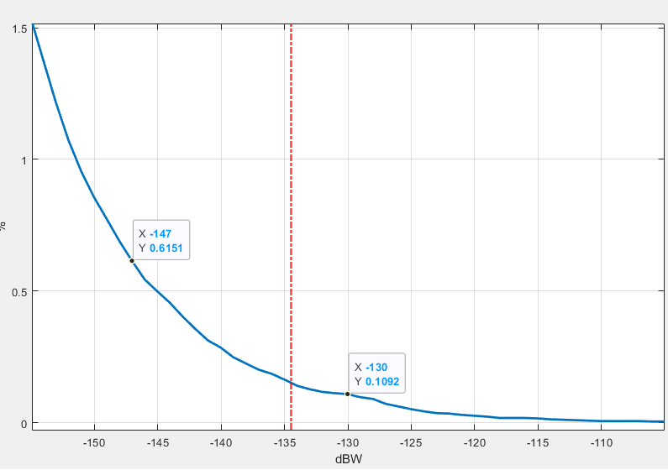
Depending on the RNSS receiver antenna gain, the protection threshold can be adjusted accordingly to read off the impacted percentage of receivers on the y-axis.
In the fixed RNSS receivers and static amateur home station case studied above, the percentage of impacted receivers in the simulation area population is less than 1% for all the most likely combinations of area setting and amateur station density. One case returns a value of 1.62% but this is considered an unlikely combination of maximum amateur station density and a rural propagation model setting. Generally, the percentage of impacted receivers is higher for the highest amateur station density case but even in the urban setting the percentage is less than 0.5%.

3 Fixed amateur home station and mobile RNSS receivers scenario
In this section the impact on moving RNSS receivers located in cars is considered. Both the amateur service narrow band emission and amateur service broadband emission with the appropriate interference threshold value are considered.

3.1 Simulation method
The first simulation step selects random locations for each car according to the vehicle density and simulation area, assigning them a random speed (from 10 to 50 km/h in urban area) and a random direction. Each car then moves along the selected heading for 15 minutes (maximum assumed amateur transmission duration). Every 5 seconds (180 individual time steps in 15 minutes), the received level is computed and compared to the RNSS receiver maximum interference threshold.
Figure 2
Mobile RNSS receiver simulation scenario
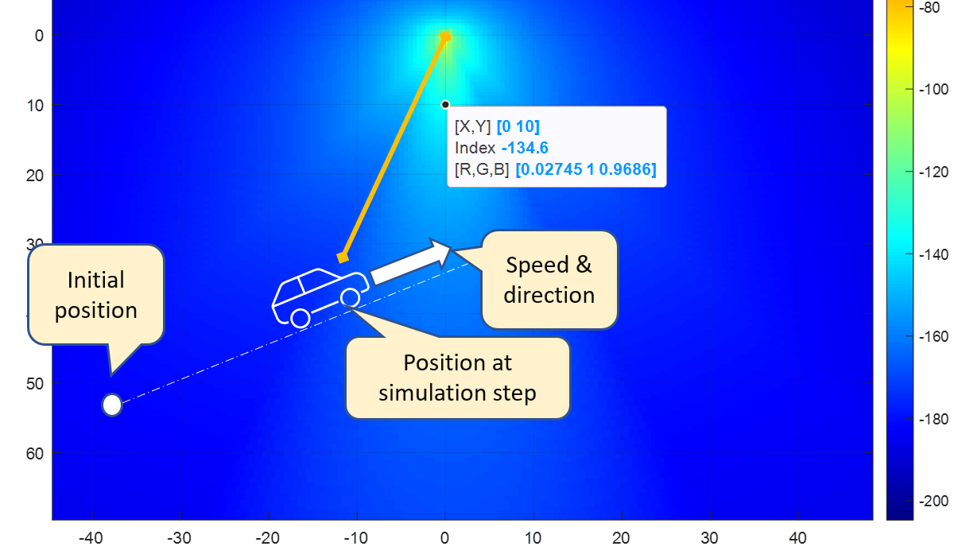
At the end of each simulation step we compute:
The percentage of “impacted” RNSS receivers that have faced interference above the protection threshold.
This process is repeated 100 times and the mean percentage and standard deviation are calculated and presented in the results.

3.2 Narrow band amateur home station

3.2.1 Simulation parameters
The same section 2.3 simulation parameters were used here with RNSS antenna gain = –6 dBi, 0 dBi and 3 dBi. The following vehicular assumptions were made:
– Car density: 330 vehicles/km² (according to ECC Report 351 for the urban case)
– Speed distribution: uniform, from 5 to 50 km/h,
– Simulated drive path duration for each simulation step: 15 minutes,
– Time step for the drive path: 5 seconds, leading to 180 steps for 15 minutes.
Note: In this simulation, if a RNSS receiver moves outside of the simulation area, it turns around back into the area. Thus the number of RNSS receivers inside the simulation remains constant.
TABLE 3
Number of mobile RNSS receivers placed in each simulation area.
Minimum amateur station density | Average amateur station density | Maximum amateur station density
2,755,500 | 825,000 | 103,125
The RNSS receiver numbers in Table 3 can be attained assuming a 50% active receivers across the population of vehicular receivers which might be pessimistic. The actual percentage of active receivers in final deployments may be higher and is yet to be determined.

3.2.2 Simulation results
Mean percentage of mobile RNSS receivers impacted by one fixed narrowband amateur home station:
Table 4
Narrow band amateur home station: mean percentage of impacted mobile RNSS
receivers and standard deviation
a) RNSS Receiver Antenna Gain = –6dBi
 | Minimum amateur station density |  | Average amateur station density |  | Maximum amateur station density
Area Setting Parameter | % Impacted RNSS Rx | Standard Deviation | % Impacted RNSS Rx | Standard Deviation | % Impacted RNSS Rx | Standard Deviation
Rural | 0.15% | 0.002% | 0.50% | 0.008% | 3.94% | 0.058%
Urban | 0.079% | 0.001% | 0.27% | 0.006% | 2.10% | 0.046%
Dense urban | 0.06% | 0.0015% | 0.21% | 0.0047% | 1.67% | 0.038%

b) RNSS Receiver Antenna Gain = 0 dBi
 | Minimum amateur station density |  | Average amateur station density |  | Maximum amateur station density
Area setting and population density | % Impacted RNSS Rx | Standard Deviation | % Impacted RNSS Rx | Standard Deviation | % Impacted RNSS Rx | Standard Deviation
Rural | 0.24% | 0.003% | 0.81% | 0.01% | 6.375% | 0.077%
Urban | 0.123% | 0.002% | 0.425% | 0.007% | 3.33% | 0.057%
Dense urban | 0.096% | 0.002% | 0.332% | 0.006% | 2.60% | 0.051%

c) RNSS Receiver Antenna Gain = 3 dBi
 | Minimum amateur station density |  | Average amateur station density |  | Maximum amateur station density
Area setting and population density | % Impacted RNSS Rx | Standard Deviation | % Impacted RNSS Rx | Standard Deviation | % Impacted RNSS Rx | Standard Deviation
Rural | 0.302% | 0.003% | 1.04% | 0.01% | 8.163% | 0.08%
Urban | 0.156% | 0.003% | 0.537% | 0.009% | 4.21% | 0.065%
Dense urban | 0.12% | 0.002% | 0.417% | 0.008% | 3.285% | 0.055%

For the mobile RNSS receiver case the percentages are higher for the maximum amateur station density case. However in the most likely combinations of area setting and station density, the percentage of impacted receivers in the simulation area population is mostly less than 1%.

3.3 Broadband amateur home station

3.3.1 Simulation parameters
The same simulation parameters and vehicular assumptions were used as detailed in section 3.2.1 but in this case using the RNSS receiver broadband interference threshold:
For the amateur service broadband emission:
– Broadband emission bandwidth: 2 MHz (DATV signal)
– Broadband RNSS receiver max interference threshold: –140 dBW/MHz (Ref: ITU-R M.1902-2, Table 1, receiver type 3b)

3.3.2 Simulation results
Mean percentage of mobile RNSS receivers impacted by one fixed broadband amateur home station:
Table 5
Broadband amateur home station: mean percentage of impacted mobile
RNSS receivers and standard deviation
 | Average amateur station density
Area Setting Parameter | % Impacted RNSS Rx | Standard Deviation
Rural | 0.612% | 0.008%
Urban | 0.325% | 0.006%
Dense urban | 0.26% | 0.01%

For an amateur station with an assumed broadband emission, the mean percentage of impacted RNSS receivers for an average amateur station density (based on narrowband station density) remains below 1%.

4 Permanent amateur station and mobile RNSS receivers scenario
In this simulation, the amateur station parameters are changed to those appropriate for a fixed permanent station (repeater station output channel) and the impact on vehicular RNSS receivers is considered from both a narrow band amateur emission and a broadband amateur emission.

4.1 Simulation method
The same simulation method was followed as used in the mobile RNSS receiver scenario in section 3.1.

4.2 Narrow band amateur permanent station

4.2.1 Simulation parameters
The following parameters identified in section 5 of the main report were assumed for the amateur permanent station and the RNSS receivers:
• Average permanent station density = 1 station / 3 333 km²
• Simulation area: According to the station density = 58 x 58 km
– Transmitter frequency: 1 297 MHz
– Transmitter e.i.r.p.: 25 Watts
– Effective height of the amateur station antenna: 25 meters
– Receiver antenna height: 1.5 meter
– Narrow band receiver max interference threshold: –134.5 dBW (Ref: ITU-R M.1902-2, Table 1, receiver type 3b).
– Receiver antenna gain: –6 dBi, omnidirectional.
– Rec. ITU-R P.1546 ‘area’ parameter: Rural, Urban and Dense Urban
– An assumption regarding clutter height* of 10 m, 20 m and 30 m were taken (available values in variable R2 in the ITU-R MATLAB code, according to rural, urban or dense urban area parameter respectively).
*: A different clatter height of 0 m is also used in a different analysis such as those in Annexes 1, 3 and 7.
– Rec. ITU-R P.1546 Location variability: 50%
– Rec. ITU-R P.1546 Required percentage time: 1%
Vehicular assumptions:
– Car density: 330 vehicles/km²
– Percentage of cars having an active RNSS receiver during the simulation: 50%
– Number of mobile RNSS receivers placed in the simulation area = 549,945.
• Speed distribution: uniform, from 5 to 50 km/h,
– Simulated drive path duration for each simulation step: 15 minutes,
The RNSS receiver numbers of 549,945 can be attained assuming a 50% active receivers across the population of vehicular receivers which might be pessimistic. The actual percentage of active receivers in final deployments may be higher and is yet to be determined.
Time step for the drive path: 5 seconds, leading to 180 steps for 15 minutes.
Note: Again, if a RNSS receiver moves outside of the simulation area, it turns around back into the area. Thus the number of RNSS receivers inside the simulation remains constant.

4.2.2 Simulation results
Mean percentage of mobile RNSS receivers impacted by one fixed narrow band permanent amateur station:
Table 6
Narrow band amateur permanent station: mean percentage of impacted mobile
RNSS receivers and standard deviation
Area setting parameter | % impacted RNSS Rx | Standard deviation
Rural | 0.24% | 0.01%
Urban | 0.13% | 0.005%
Dense urban | 0.1% | 0.005%
For the permanent narrow band amateur station and mobile RNSS receiver case only a single average density figure is available. All the mean percentage results for impacted RNSS receivers are less than 1%.

4.3 Broadband amateur permanent station

4.3.1 Simulation parameters
The same simulation parameters and vehicular assumptions were used as detailed in section 4.2.1 but in this case using the RNSS receiver broadband interference threshold:
For the amateur service broadband emission:
– Broadband emission bandwidth: 2 MHz (DATV signal)
– Broadband RNSS receiver max interference threshold: –140 dBW/MHz (Ref: ITU-R M.1902-2, Table 1, receiver type 3b).

4.3.2 Simulation results
Mean percentage of mobile RNSS receivers impacted by one fixed broadband amateur permanent station:
Table 7
Broadband amateur permanent station: mean percentage of impacted mobile
RNSS receivers and standard deviation
Area setting parameter | % impacted RNSS Rx | Standard deviation
Rural | 0.68% | 0.01%
Urban | 0.34% | 0.01%
Dense urban | 0.26% | 0.01%

For the permanent broadband amateur station and mobile RNSS receiver case only a single average density figure is available. All the mean percentage results for impacted RNSS receivers are less than 1%.

5 Summary
This study presents an example of how to assess the impact of certain amateur station emissions on a deployment simulation of a large number of one type of co-frequency RNSS (space-to-Earth) receivers.

